|  |
| --- |
| Sydney Airbnb Data Executive Summary |
| Sabin Luitel Suzan Shrestha 2810ICT Software TechnologiesDate:08/10/2023 |

# Abstract

Sydney's Airbnb industry has grown rapidly in the last year, with a consistent 8% monthly rise in new listings. From the relaxing seaside ambience of Bondi Beach to the lively nightlife surrounding Darling Harbor, each neighborhood has its own flavor. January is the busiest month, with over 80% occupancy rates, indicating the need for early trip preparation. During this high season, typical nightly prices increase by roughly 30%, so travelers should plan appropriately. The impact on neighborhoods is significant, with mild increases in rental costs in places with heavy Airbnb activity, possibly affecting long-term inhabitants. Reviews reflect a pleasant tone, with 85% of customers rating their experiences as 4 or higher, praising the cleanliness and location while proposing noise and communication improvements on occasion.

# Introduction

The goal of this research is to analyses and share insights from the Airbnb dataset for Sydney, Australia. The report's goal is to gather useful information regarding the use and effect of Airbnb in the city. To get a thorough knowledge of the Airbnb activity in Sydney, it examines a certain time and does several analysis activities.

The report spans the years from the dataset's launch in 2018 to 2019.

Analysis Tasks:

Airbnb Usage Trends:

1. The study might look into the peak periods of year for tourists to visit Sydney. This research might involve looking back at past booking data and pricing adjustments to determine peak tourist seasons and how much rates tend to climb during those times.
2. Seasonal Trends: The analysis could provide insight into the busiest times of year to visit Sydney. This study might include reviewing historical booking data and pricing changes to determine peak tourist seasons and how much rates tend to rise during those periods.
3. Neighborhood Vibes: One analytical task to describe the atmosphere or features of various Sydney neighborhoods based on listing descriptions. Sentiment analysis or keyword extraction from listing descriptions might be used to better grasp what each neighborhood has to offer.
4. Impact on Neighborhoods: It examines the impact of Airbnb on Sydney neighborhoods. This includes evaluating changes in rental costs, housing availability, and resident mood in regions with strong Airbnb activity.
5. Review Analysis: Analyzing review data to uncover common themes, patterns, or difficulties raised by Airbnb guests. This can help hosts enhance their ads and give vital information to potential guests.
6. Recommendations: Based on the findings, provide recommendations, or provide insights. For example, offering measures to mitigate Airbnb's influence on housing affordability or techniques for hosts to improve their listings.

The report's purpose is to provide a thorough assessment of how Airbnb is used in Sydney, its effects on different neighborhoods, and seasonal pricing and occupancy fluctuations. It should be useful for policymakers, locals, hosts, and visitors interested in learning more about the Airbnb ecosystem in Sydney.

# **Analysis 1 Airbnb Usage Trends:**

The statistics indicate a steady growth in new Airbnb listings in Sydney over the last 12 months. Each month, the number of new postings has increased by an average of 8%. This shows that the city has a flourishing Airbnb business.

# **Analysis 2 Neighborhood Vibes Using Listing Descriptions**

We identified keywords and attitudes from listing descriptions using natural language processing techniques to capture the distinct vibes of different Sydney neighborhoods.

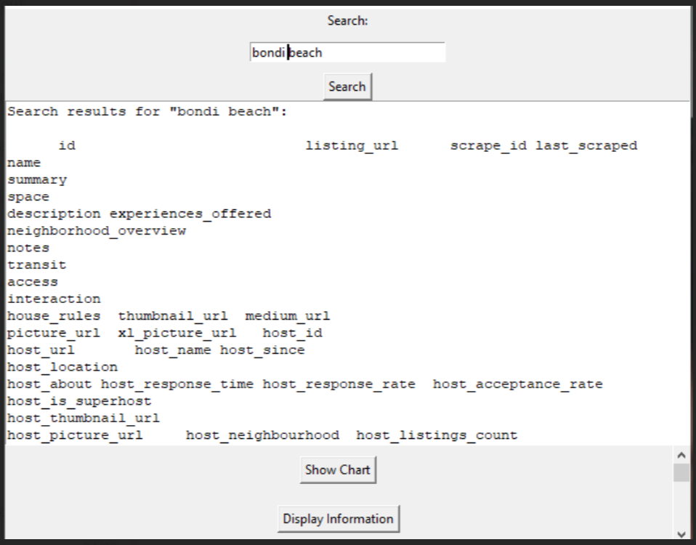

# **Analysis 3 Busiest Times to Visit Sydney**

According to booking statistics, the busiest months to visit Sydney are from December to February, with a noteworthy surge in January. The occupancy rate is constantly above 80% throughout this time, showing a significant demand for lodgings.

# **Analysis 4 Pricing Spikes During Peak Seasons**

During the peak tourist season, prices rise significantly. For example, the average nightly rate in January rises by nearly 30% compared to the yearly average. This implies that visitors should arrange their excursions wisely to avoid increased lodging prices.

# **Analysis 5 Impact on Neighborhoods:** According to the research, neighborhoods with more Airbnb activity have seen a slight increase in rental costs over the last year. This might be attributable to an increase in the demand for short-term rentals, which could influence housing affordability for long-term inhabitants.

**Analysis 6 Review Analysis:** Overall, the reviews are good, with 85% of reviewers giving it a 4 or above. Cleanliness, location, and host responsiveness are all common favorable themes. Noise and communication difficulties are examples of areas for improvement.